**AIM:** To Develop Distributed System

**PROBLEM STATEMENT:**

Design and develop a basic prototype distributed system (e.g. a DFS).

**PREREQUISITES:**

JAVA Programming

#### COURSE OBJECTIVE:

To understand the concept of Distributed system ,remote method invocation and Remote Procedure Calls

#### COURSE OUTCOME:

Able to learn and apply the concept of remote method invocation and Remote Procedure Calls

#### THEORY:

A distributed file system (DFS) is a file system with data stored on a server. The data is accessed and processed as if it was stored on the local client machine. However, the servers have full control over the data and give access control to the clients.

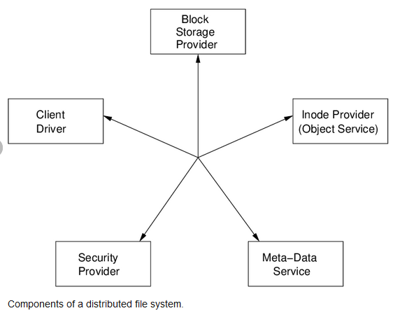

A file service is a specification of what the file system offers to clients. A file server is the implementation of a file service and runs on one or more machines. A file itself contains a name, data, and attributes (such as owner, size, creation time, access rights).

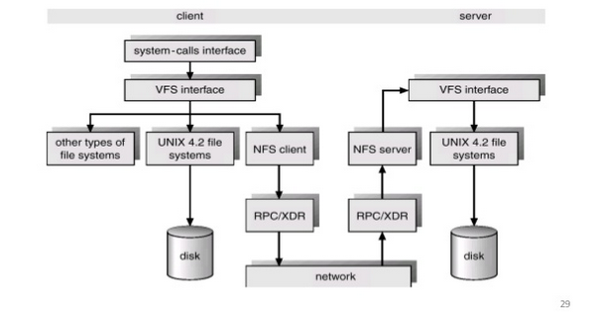

An immutable file is one that, once created, cannot be changed. Immutable files are easy to cache and to replicate across servers since their contents are guaranteed to remain unchanged. Two forms of protection are generally used in distributed file systems, and they are essentially the same techniques that are used in single-processor non-networked systems: capabilities Each user is granted a ticket (capability) from some trusted source for each object to which it has access.

The capability specifies what kinds of access are allowed. access control lists Each file has a list of users associated with it and access permissions per user. Multiple users may be organized into an entity known as a group.

File service types To provide a remote system with file service, we will have to select one of two models of operation. One of these is the upload/download model. In this model, there are two fundamental operations: readfile transfers an entire file from the server to the requesting client, and write filecopies the file back to the server.

It is a simple model and efficient in that it provides local access to the file when it is being used. Three problems are evident. It can be wasteful if the client needs access to only a small amount of the file data. It can be problematic if the client doesn't have enough space to cache the entire file. Finally, what happens if others need to modify the same file? The second model is a remote access model.

The file service provides remote operations such as open, close, read bytes, write bytes, get attributes, etc. The file system itself runs on servers. The drawback in this approach is the servers are accessed for the duration of file access rather than once to download the file and again to upload it. Another important distinction in providing file service is that of understanding the difference between directory service and file service.

A directory service, in the context of file systems, maps human-friendly textual names for files to their internal locations, which can be used by the file service. The file service itself provides the file interface (this is mentioned above).

Another component of file distributed file systems is the client module. This is the client-side interface for file and directory service. It provides a local file system interface to client software (for example, the vnode file system layer of a UNIX kernel).

**Advantages**

1. Resource sharing − Sharing of hardware and software resources.
2. Openness − Flexibility of using hardware and software of different vendors.
3. Concurrency − Concurrent processing to enhance performance.
4. Scalability − Increased throughput by adding new resources.
5. Fault tolerance − The ability to continue in operation after a fault has occurred.

**Disadvantages**

1. Complexity − They are more complex than centralized systems.
2. Security − More susceptible to external attack.
3. Manageability − More effort required for system management.
4. Unpredictability − Unpredictable responses depending on the system organization and network load.

**Applications**

1. Global positioning System
2. World Wide Web
3. Air Traffic Control System
4. Automated Banking System

**CONCLUSION:**

Thus, students understood how to develop DFS

**FAQs:**

What is DFS?

What is meant by file system?

What is immutable file/?